1. Realiza con el simulador una puerta AND de 2 entradas con transistores tipo N.
2. Realiza con el simulador una puerta OR de 2 entradas con transistores tipo N.
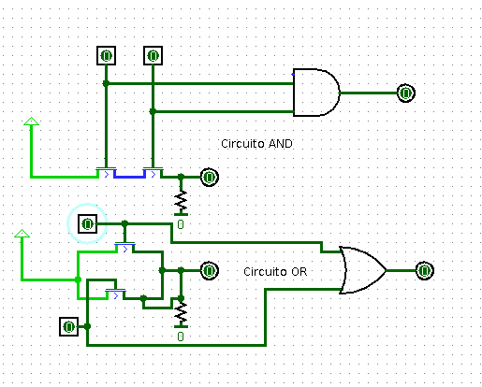

3. Implementa con puertas lógicas las funciones siguientes, escribe sus tablas de
verdad y comprueba si los resultados son correctos con el simulador, captura
una imagen de cada circuito en funcionamiento.
a) F=(a+b+c’)+(a+b)’

A | B | C | A+B | C’ | A+B+C’ | (A*B)’ | F
0 | 0 | 0 | 0 | 1 | 1 | 1 | 1
0 | 0 | 1 | 0 | 0 | 0 | 1 | 1
0 | 1 | 0 | 1 | 1 | 1 | 1 | 1
0 | 1 | 1 | 1 | 0 | 1 | 1 | 1
1 | 0 | 0 | 1 | 1 | 1 | 1 | 1
1 | 0 | 1 | 1 | 0 | 1 | 1 | 1
1 | 1 | 0 | 1 | 1 | 1 | 0 | 1
1 | 1 | 1 | 1 | 0 | 1 | 0 | 1

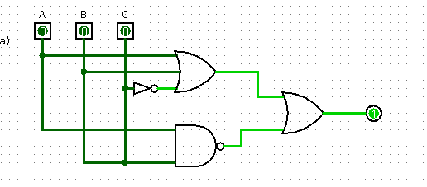

b) F=[(a+b)*(a*b)’]+(b*c’)

A | B | C | A+B | (A*C)’ | (A+b)*(A*C)’ | B*C’ | F
0 | 0 | 0 | 0 | 1 | 0 | 0 | 0
0 | 0 | 1 | 0 | 1 | 0 | 0 | 0
0 | 1 | 0 | 1 | 1 | 1 | 1 | 1
0 | 1 | 1 | 1 | 1 | 1 | 0 | 1
1 | 0 | 0 | 1 | 1 | 1 | 0 | 1
1 | 0 | 1 | 1 | 0 | 0 | 0 | 0
1 | 1 | 0 | 1 | 1 | 1 | 1 | 1
1 | 1 | 1 | 1 | 0 | 0 | 0 | 0
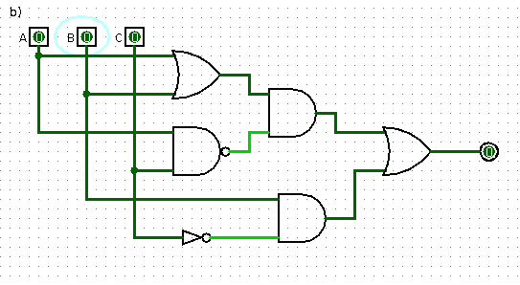

c) F= (a+c)’(+)(a*b*c)’

A | B | C | (A+C)’ | (A*B*C)’ | F
0 | 0 | 0 | 1 | 1 | 0
0 | 0 | 1 | 0 | 1 | 1
0 | 1 | 0 | 1 | 1 | 0
0 | 1 | 1 | 0 | 1 | 1
1 | 0 | 0 | 0 | 1 | 1
1 | 0 | 1 | 0 | 1 | 1
1 | 1 | 0 | 0 | 1 | 1
1 | 1 | 1 | 0 | 0 | 0

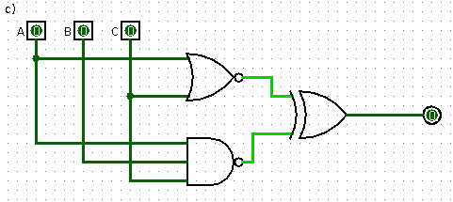

d) F= [[(a+(b+c)’]+[(a*b’)+(a*d)]]’

A | B | C | D | (B+C)’ | A+(B+C)’ | A*B’ | A*D | (A*B’)+(A*D) | F
0 | 0 | 0 | 0 | 1 | 1 | 0 | 0 | 0 | 0
0 | 0 | 0 | 1 | 1 | 1 | 0 | 0 | 0 | 0
0 | 0 | 1 | 0 | 0 | 0 | 0 | 0 | 0 | 1
0 | 0 | 1 | 1 | 0 | 0 | 0 | 0 | 0 | 1
0 | 1 | 0 | 0 | 0 | 0 | 0 | 0 | 0 | 1
0 | 1 | 0 | 1 | 0 | 0 | 0 | 0 | 0 | 1
0 | 1 | 1 | 0 | 0 | 0 | 0 | 0 | 0 | 1
0 | 1 | 1 | 1 | 0 | 0 | 0 | 0 | 0 | 1
1 | 0 | 0 | 0 | 1 | 1 | 1 | 0 | 1 | 0
1 | 0 | 0 | 1 | 1 | 1 | 1 | 1 | 1 | 0
1 | 0 | 1 | 0 | 0 | 1 | 1 | 0 | 1 | 0
1 | 0 | 1 | 1 | 0 | 1 | 1 | 1 | 1 | 0
1 | 1 | 0 | 0 | 0 | 1 | 0 | 0 | 0 | 0
1 | 1 | 0 | 1 | 0 | 1 | 0 | 1 | 1 | 0
1 | 1 | 1 | 0 | 0 | 1 | 0 | 0 | 0 | 0
1 | 1 | 1 | 1 | 0 | 1 | 0 | 1 | 1 | 0

